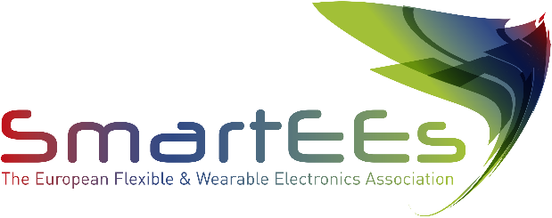

ROLLUP

# 

# Ab.Acus srl

Ab.Acus’ research is currently investigating **digital health**, **transparent technologies**, **self-tracking systems**, **localization devices**, and **simulation and modelization techniques**, needed to make multifaceted phenomena understandable by stakeholders and citizens.

**https://www.ab-acus.eu**

# 

# Problem to be solved

There is an increasing need of solutions that can support and positively impact on the management of the upper limb neurorehabilitation path from the point of view of both the quality of the provided service and adherence to the therapy. Main impairments targeted by the solution is stroke. Most of societal costs related to stroke are due to the high rate of rehospitalization of not treated chronic patients and the indirect costs of ambulatory treatment for outpatients (e.g. transport and assistance). Flexible home rehabilitation and monitoring systems are needed to provide high quality care to a growing population of patients, while containing the associated costs.

# Solution provided by SmartEEs

To enhance home rehabilitation implementation for stroke survivors, Ab.Acus developed a radically new solution (RehabMe), exploiting RF to track limbs movements and guide the therapy at home. Solution consists of wearable device and an interactive visual flexible workspace, which is able to guide the patient in the execution of rehabilitation therapy using light stimuli. By applying flexible electronics, a fully rollable and light prototype, able to provide light-based guidance using a dense LEDs matrix, was implemented. The prototype is controllable through Bluetooth communication, enabling an easy and transparent integration with the RehabMe system.

# Business model & impact

Routes to Market: 1) License the technology, 2) sell via distributors, 3) Sell direct to large public and private organisations or 4) Lease to independent practitioners. AE is expected to create new jobs for the project business partners in EU as well as create new collaboration with other companies, research institutes and academic organizations. And bring turnover to IC via selected business models.