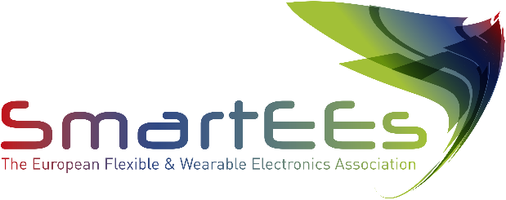

Flexible & Wearable Electronics

Application Experiments

# Imatge que conté text, electrodomèstic Descripció generada automàticament

# 

# Company Profile

Infarmate is a Spanish company that seeks to improve the health of polymedicated patients, through pharmacotherapeutic follow-up and greater adherence to therapeutic adherence.

**https://infarmate.es/**

# Problem to be solved

Non-adherence to medication of chronic poly-medicated patients is an unsolved global problem, which affects the EU, reaching, in some countries, levels over 50%. Its consequences in Europe are of 200,000 premature deaths per year and an annual cost of 125,000 M€ borne by healthcare systems. Current solutions are either only partial or unaffordable.

# Solution provided by SmartEEs

SIGUEMED consists on a smart blister pack (similar to a normal blister pack but with printed electronic circuits in the sealing foil) attached to a base dock with embedded connectivity. Wearables are connected via Bluetooth and beep to remind of intake time. The base dock communicates with a SW platform, to register if and when pills intake takes place. In case of non-compliance, it sends non-intake alerts to the people assigned as contact person.

# Business model & impact

SIGUEMED is an eHealth solution that helps poly-medicated chronic patients enhance their medical adherence, operation therefore in the Global Medication Adherence Enhancement Market. This market reached globally a value of nearly $2,438.2 million in 2020 and it is expected to reach $4,181.3 million in 2025. The SmartEEs experiment has supported SIGUEMED in a thorough market analysis, in the validation of the business model and in outlining the funding mechanisms for receiving the financial support needed to develop and produce the product.